Explainable AI

Explanation
This hask has been divided into three parts. Each of the parts is briefly explained first and then for each emotion and for each sentence in this emotion a graph is included with explanaiting and intrepretation below.

Basic Gradient x Input

This method multiplies the gradient of the output with respect to each input by the input itself, giving a first look at which tokens are influencing the model’s decision. This method struggles with transformers due to attention and layer normalization so it may not precisely reflect the behaviour of model

Neutral
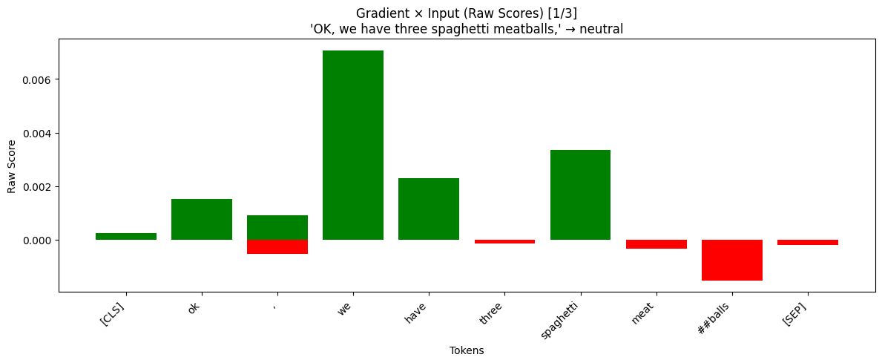
First class to analyse is the neutral class. The sentences are each ran through the model and gradient x input code to calculate scores and display the results. All of the neutral sentences were correctly labeled as neutral.
Dominant part of the tokens are in the positive values. This means that this sentence is supported for the neutral class mainly by words „we“, „have“ and „spaghetti“. Only word that deflects in this sentence is balls. Although the original word in the transcript is meatballs, it gets separated and the word may be interpreted in different classess during pre-training.

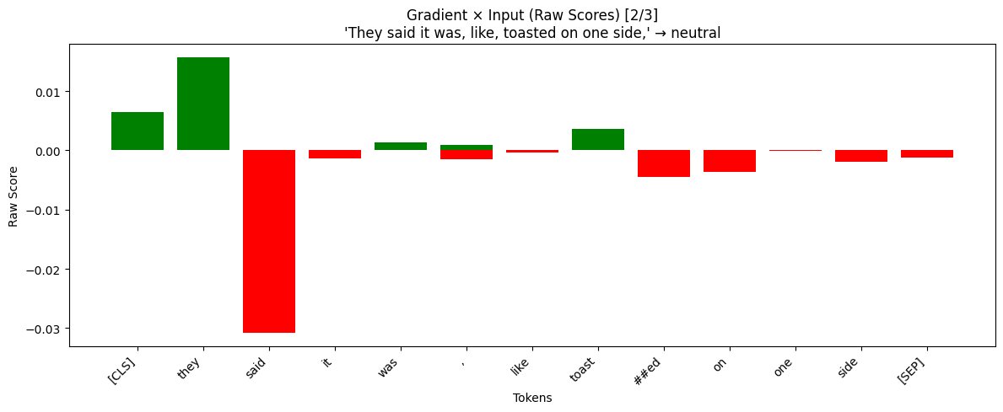
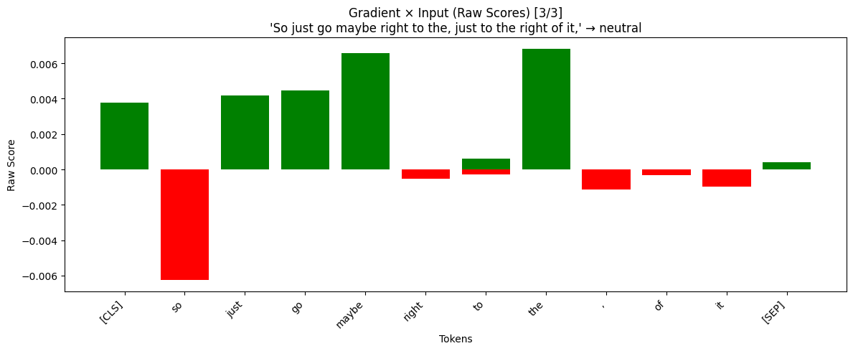
Most of the tokens are near zero which would suggest the neutrality, however the first three tokens are have much bigger impact on the decisions. The [CLS] token is signals the model the beginning of sentence, so it should not hold any meaning, so in this case we can see a small bias towards the neutral class. The word “they“ has the highest positive significance, but “said” is even stronger and pushing more towards a different class. We think that the model correctly predicted neutral because the values of positive and negative gradients got close to 0, but it is important to mention that if the [CLS] class was not present, this sentence might have been predicted incorrectly
Here we see the model is again more confident about the neutral class. However we see a higher bias on the [CLS] token. The whole sentence overall does not have any meaning, so seeing the only word „so“ having negative impact on the prediction stil makes the model confident in this class.

Happiness
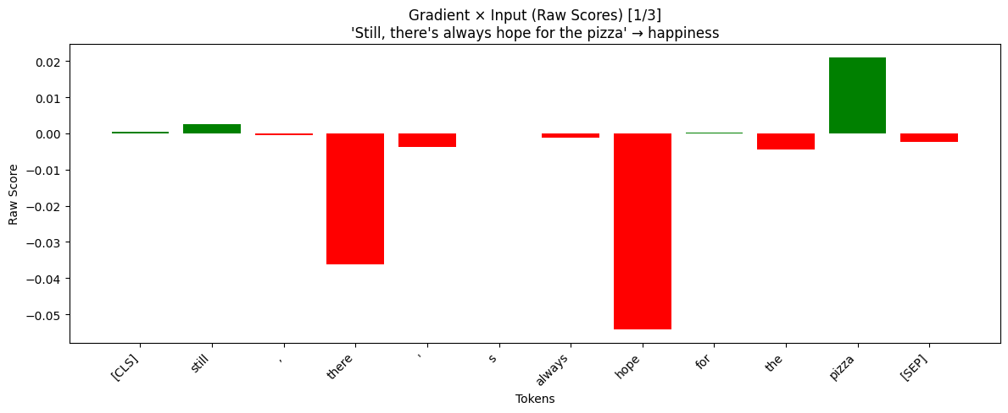
For the selected happiness sentences only one out of three was correctly assigned. We will look deeper into the outputs to see why is that.
Even with strong negative values for there or hope, which hope we think should be positive, the model managed to predict the class correctly. This shows us that there is some bias present.
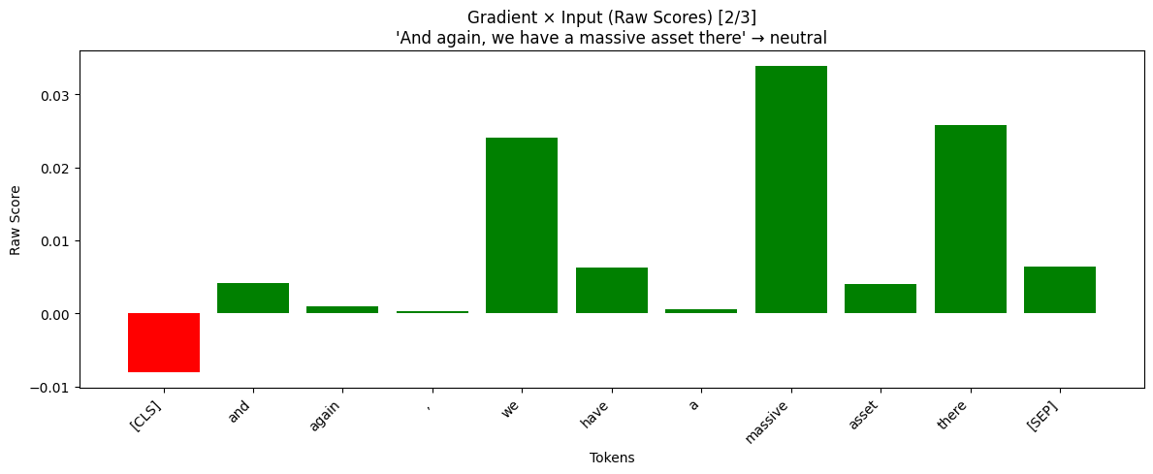
This sentence has been labeled as neutral with multiple words supporting it. Interesting to see is that the combination of massive and asset are poiting both to the neutral prediction, where massive poses quite the strong emotion.

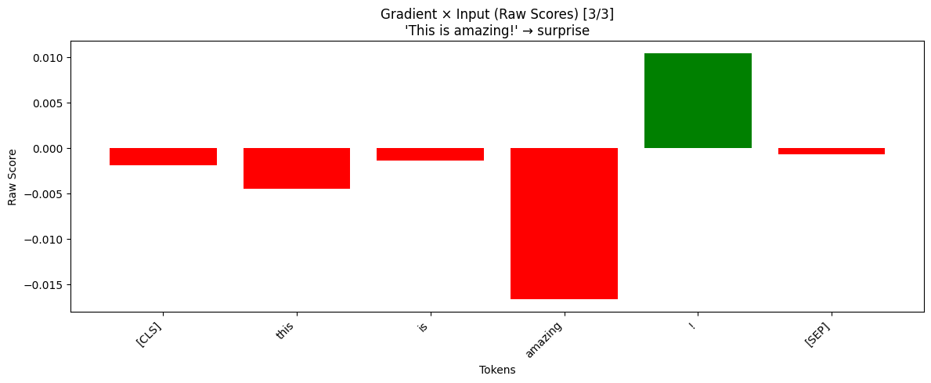
By far the biggest the biggest surprise that a simple sentence like this with strong positive motive is assigning surprise intead of happiness. Most of the tokens point towards another class except the explanaition mark. Even after removing it the prediction stays the same and the entire graph is red. This may suggest that the model is not confient in all the emotions but it seems that surprise is the highest of them.

Sadness
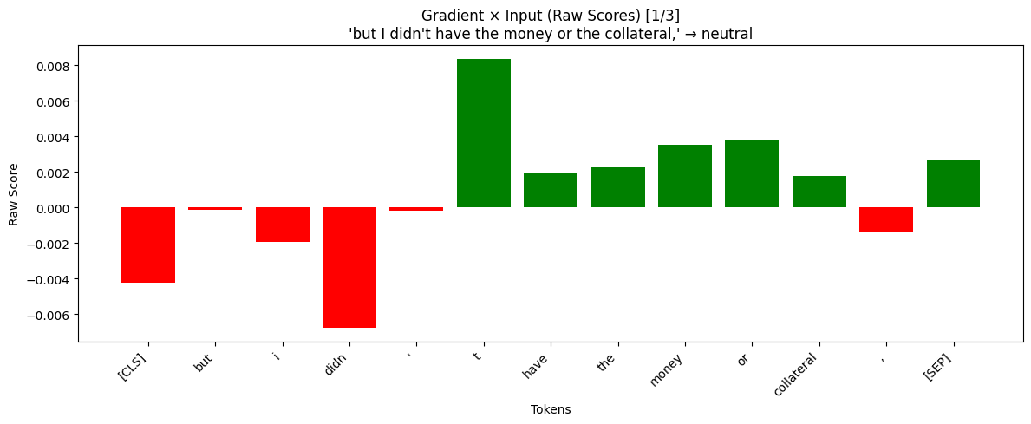
These sentences suffered from the same unsuccsefful prediction rate where only one out of three was correct.
This sentence which was incorrectly labeled as neutral has a high negative value for „didn“ which could support the sadness label, but then the majority of words push for neutral making it go with this emotion.

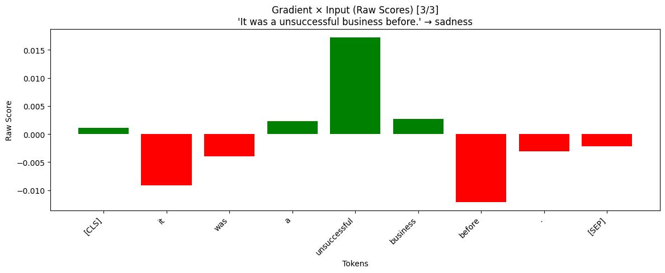
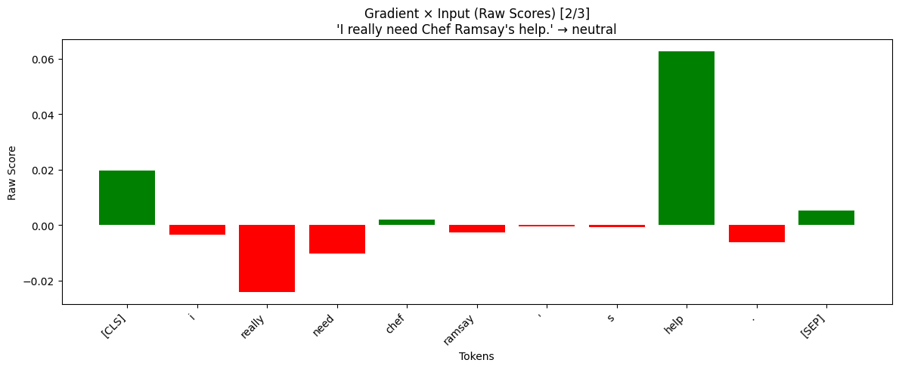
In this example we suppose that an emotionally significant word like „help“ should have been indicating another emotion, yet in this case it supports the neutral class. This goes againsts our expectations
Finally one corect sentence shows that „unsuccesful“ was very important for sadness, but other unrelated words like „it“ or „before“ were pushing towards something else.

Anger
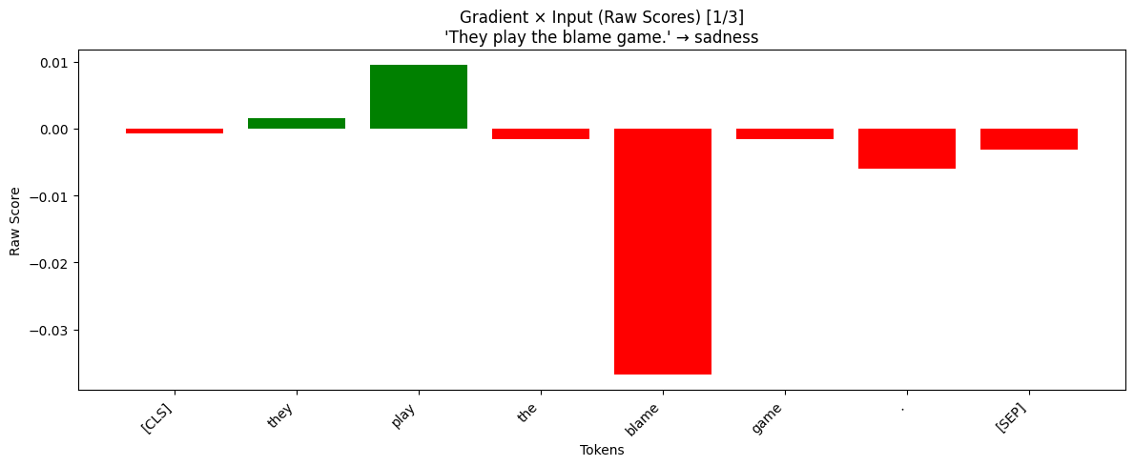
Same as previous two. Model got only one of ouf three right.
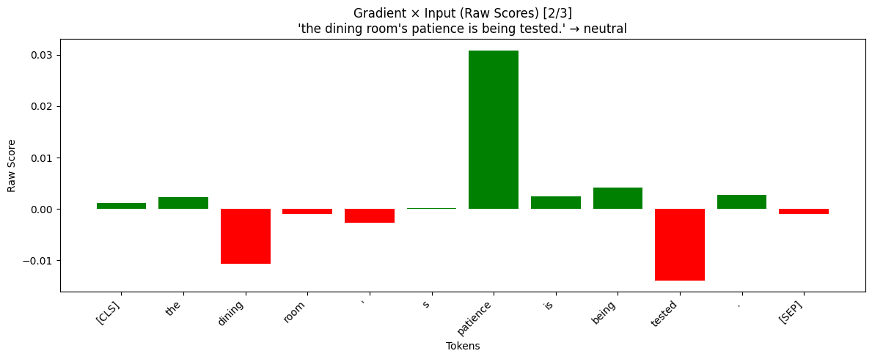
Although this sentence has a true label as anger, this was probably influenced by us knowing the context. Looking at the graph we see that it is mostly red with only two tokens supporting the sadness and „blame“ having a strong negative effect. Probably what happened again is that out of all the emotions sadness had the highest score with anger being just behind.
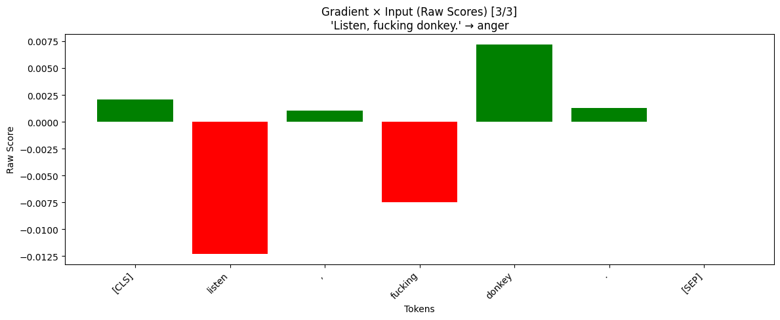
In this sentence we were hoping the model would consider patience and tested as indicators of anger, but as we see in the graph “patience” is supporting neutral and only “tested” is leaning towards another emotions. Other tokens have relatively small influences.
This sentence was correctly labeled. But we expected the word “fucking” be supported in this class. That comes to us as a surprise that profanity points to a different emotion.

Disgust
Disgust has one out of three correct, however after looking carefully at the sentences, it is again clear that a human has all the context clues for some examples and correctly assigns the emotion, while our model can’t make that connection.
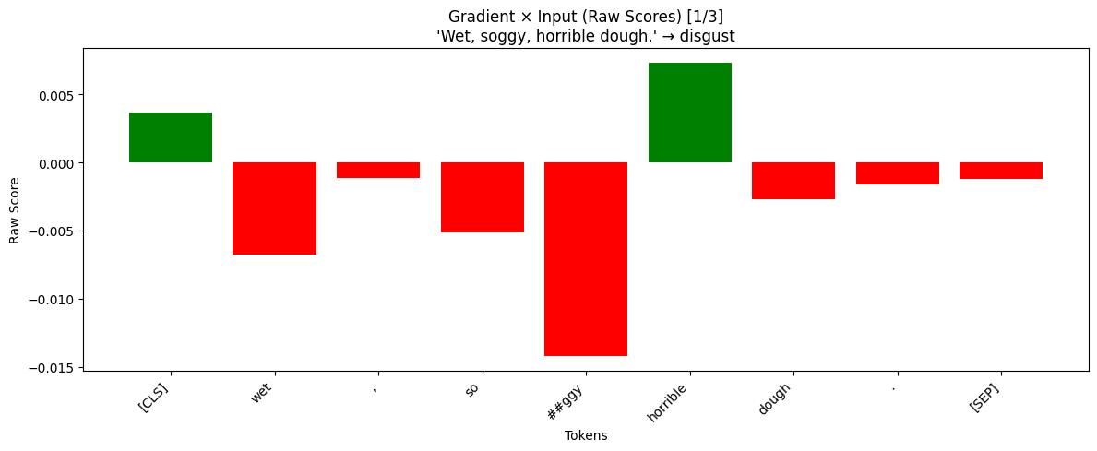
Again, the graph shows more red than expected. We expected “wet“ to be pushing towards the disgust class. Especially when it comes to food, but hence the previous explanation that point to the model missing context.
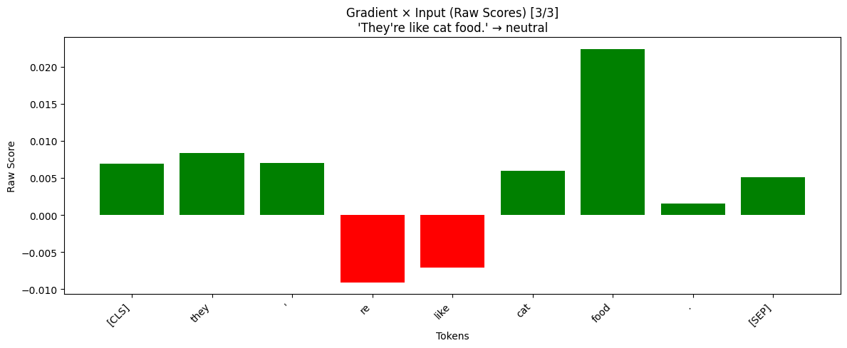
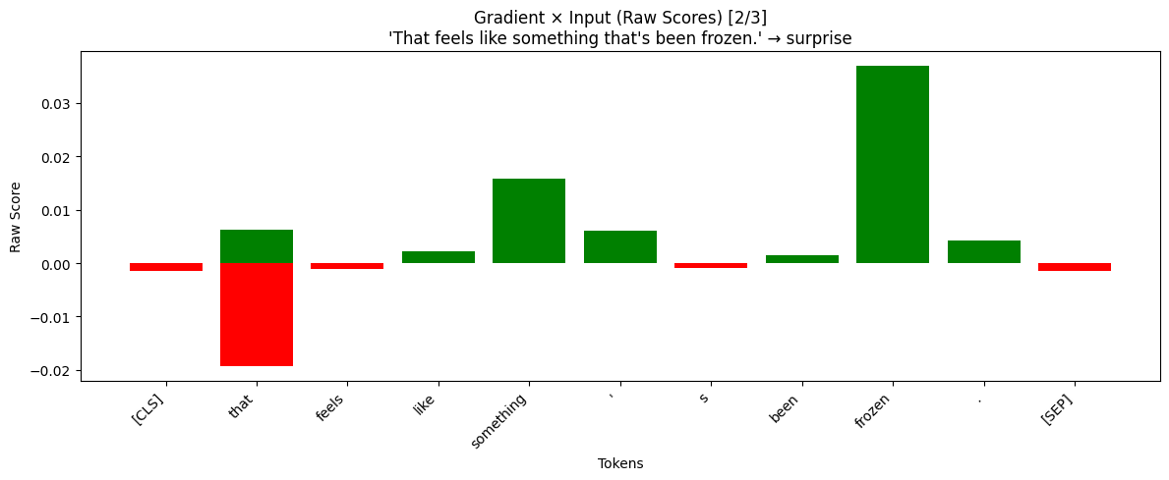
This example is interesting, because we think the sentence can be both disgust and surprise. It’s interesting to see frozen as surprise, which again, in the context, people may be surprised taste food that has been frozen but also disgusted.
Perfect example of a sentence that is neutral without context, but in a kitchen setting with food in the picture, this should have been disgust clearly. Maybe the “are” and “like” do point to disgust, but words like “cat” or “food” totally make sense to be in a neutral context

Fear
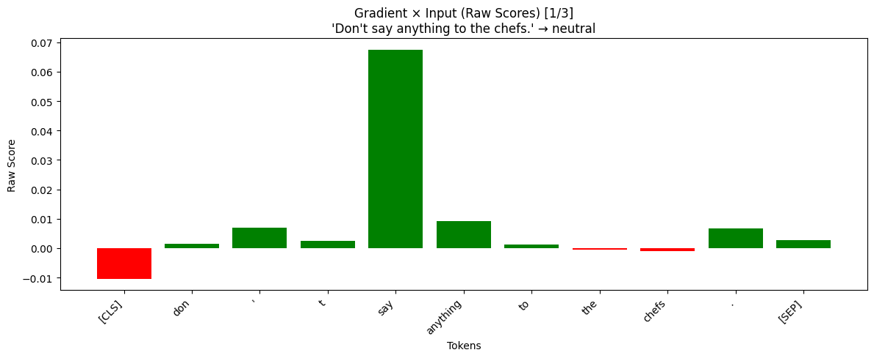
Continuing with the trend of the model assigning wrong label because of lack of context clues. Once again one out of three examples were correct.
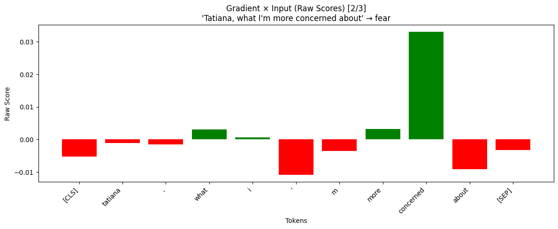
This sentence is completely supported for neutral by the model, which makes complete sense looking at it from a sentence alone perspective. But as we recall from the show, the owner was saying this with concern that if the chefs knew about something, they would be angry. This case is purely context related issue
This sentence has been correctly assigned, and the tokens support the emotion.
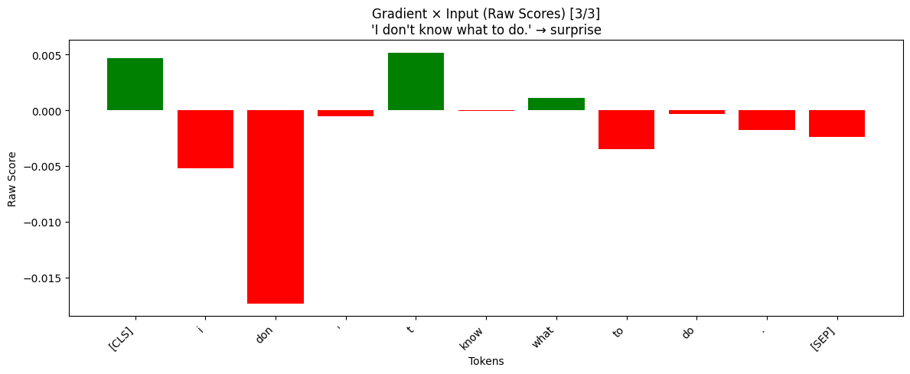
This prediction does not make sense to us, because even with fear being maybe vague and context related, there is no way this sentence is surprise. If it were labeled as sadness, that could be understood, but this is just plain wrong.

Surprise
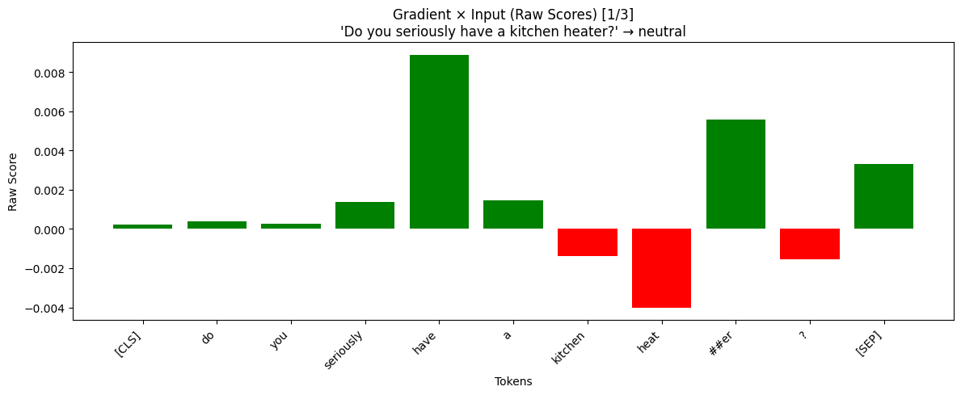
Our last emotion did not break the trend, and the model only got one out of three examples.
We expected the token “seriously” to be in the negative values for neutral, but out of all the tokens only symbol “?” makes sense and is pointing to other emotion. The sentence alone would be neutral, but again, the context in this case matters.

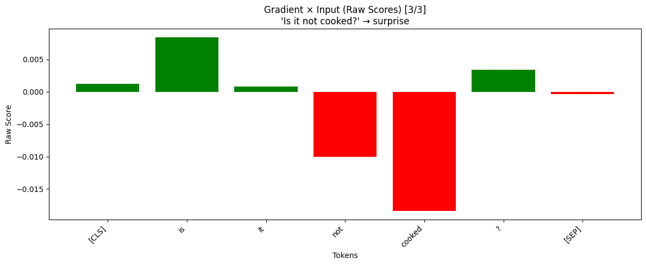
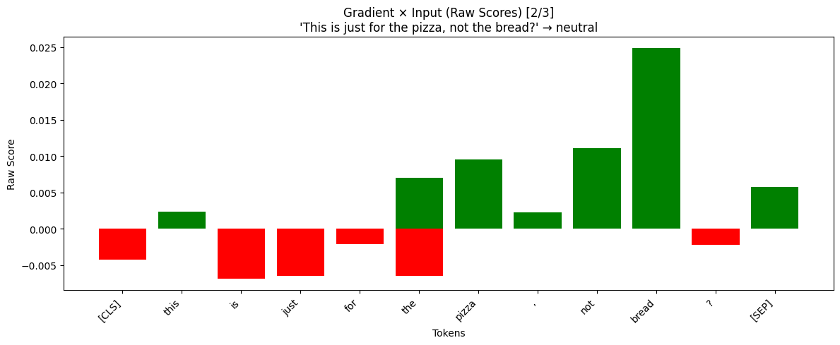
Here in this sample, foods are pointing towards neutral and that if fine, but we notice that the “?” symbol is not supporting this. It would be interesting to see if we force the model to always label sentence as surprise when it encounters this symbol, whether it improves the overall accuracy of the model. But it is a good sign that the bar is red and not green.
Final sentence with correct label supports the previous insight that the question mark symbol indeed is supported in the surprise label. Then the word “is” has high impact, but we don’t necessarily think this is correct. Our guess for the red bars is that they point to sadness class, since in the sadness section the token “t” which is short form of “not” in “didn’t” is indeed positive.

Improved Explanation with Conservative Propagation (Layer-wise Relevance Propagation)
This method is more stable and accurate than the previous one. With the conservative LRP used, this technique improves the basic one with carefully redistributing the relevance using attention weights and normalization values, making the explanations more stable, consistent and reflective of model behavior.

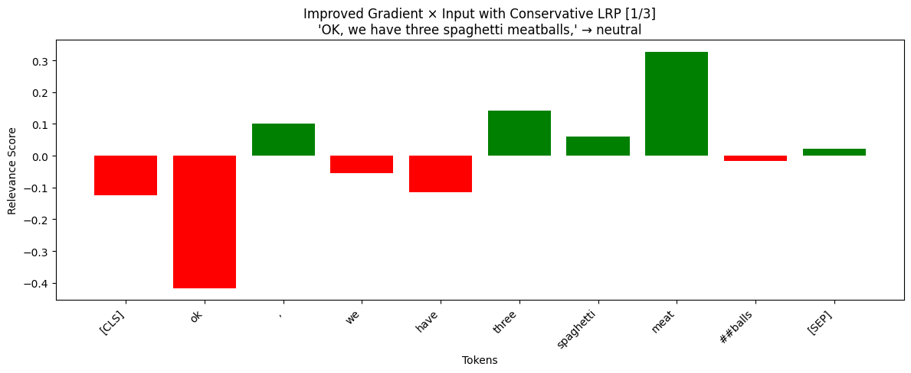
Neutral
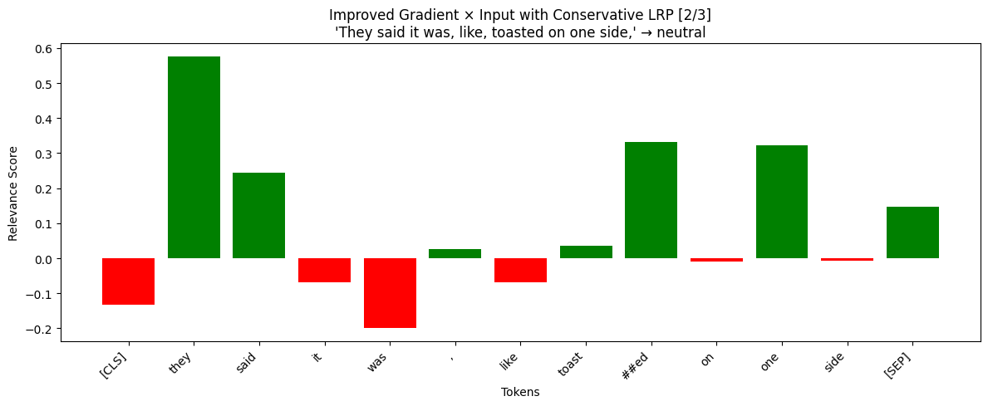
Going over the tokens again, our theory about food is right. The food supports the neutral class, however the token “ok” is not much more irrelevant for neutral and points probably to other positive class, which makes sense.
More neutral tokens like “they”, “said”, “one” are supportive of the class which is an improvement from the previous method, since here we see the model is confident in this class, where before it was only slightly.
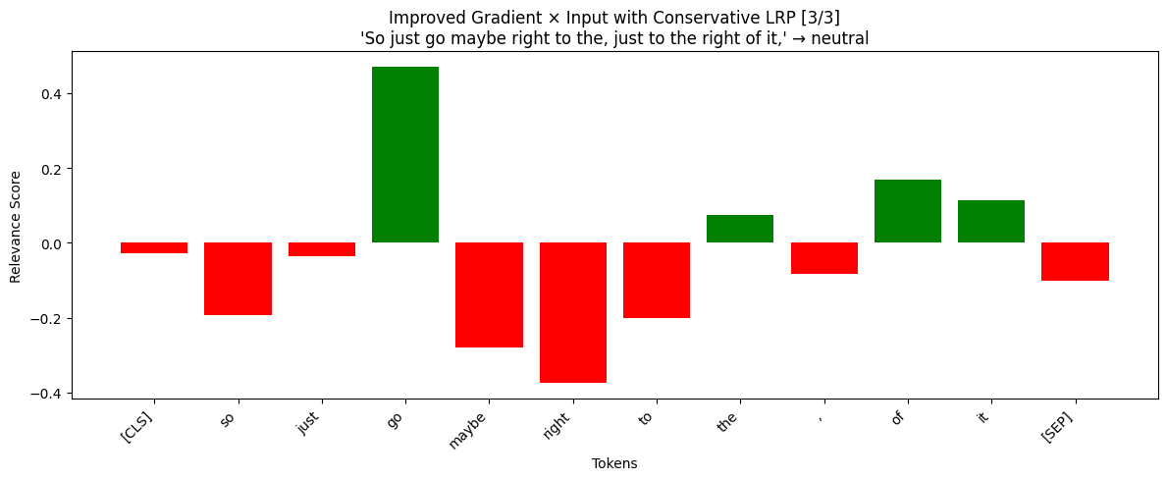
In this case the [CLS] token no longer holds that big of a bias, but we see a difference that now the highest relevance is positive on the word “go”, but many other tokens are now in the negative values, yet the model still predicts neutral instead of happiness. This may be because the model is not that confined in all the emotions, but the neutral had the highest probability.

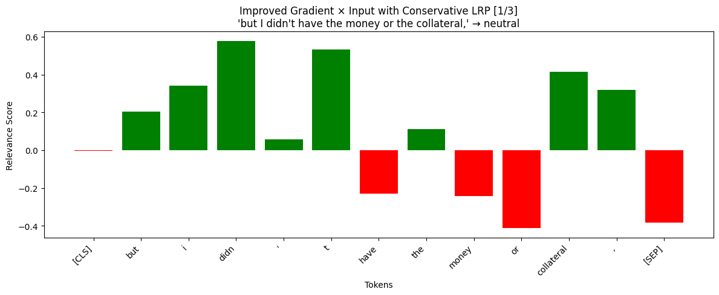
Sadness
Comparing this improved method with the previous, now the first half of the sentence which holds negative emotion is considered as supportive of the neutral class. This is quite the major mistake our model does.
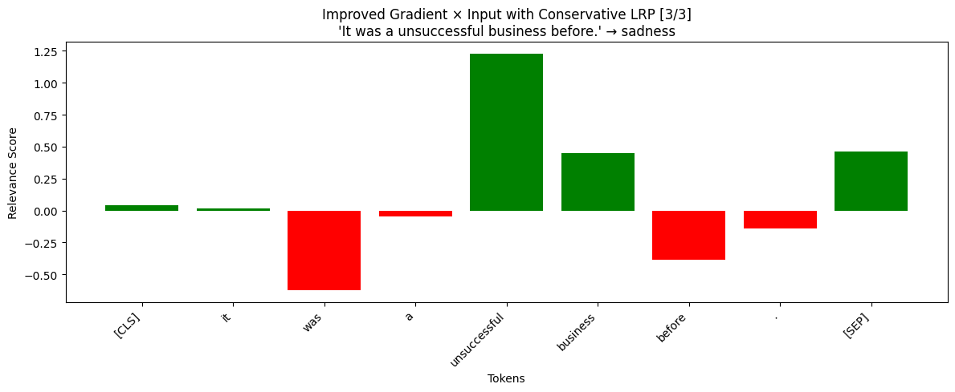
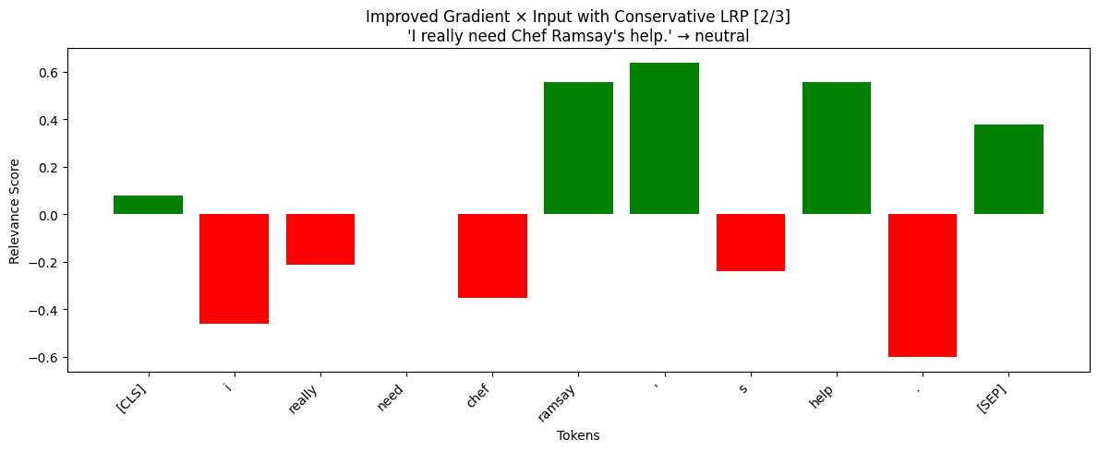
Compared to the previous method, now the model is not so confident, because there are a lot tokens with negative relevance, but also other tokens support the class. Here we see that the name is also considered as highly impactful which should’ve been near zero. In further examples we will take a closer look if other names could be pointing to neutral class, which would be a clear issue and bias with our model.
The token “unsuccessful” stayed the most relevant for sadness and we see that “was” is not moderately irrelevant for sadness and now “it” has almost no relevancy.

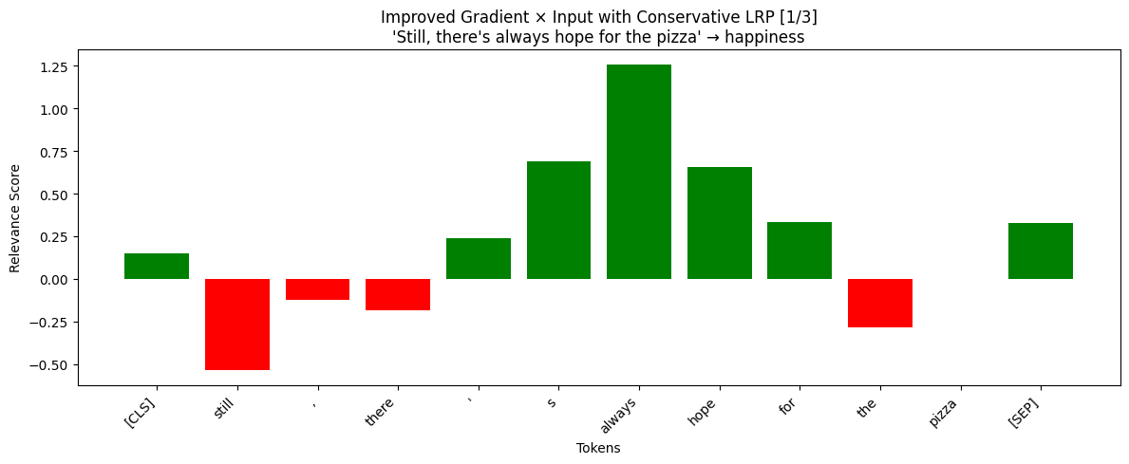
Happiness
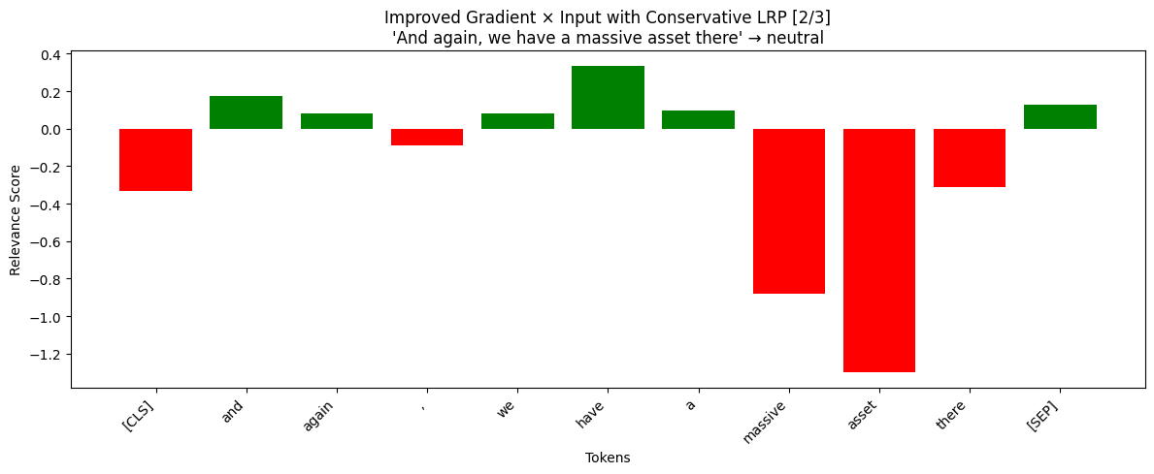
With this improved method we have a clear understanding of which tokens are important. This is an improvement from the previous, because now we see that it correctly responds to emotionally relevant tokens.
Even with wrong class predicted, the positive tokens which contain happiness are now showing us high negative relevance to neutral. They most likely point to happiness, but the models’ prediction unfortunately is wrong.

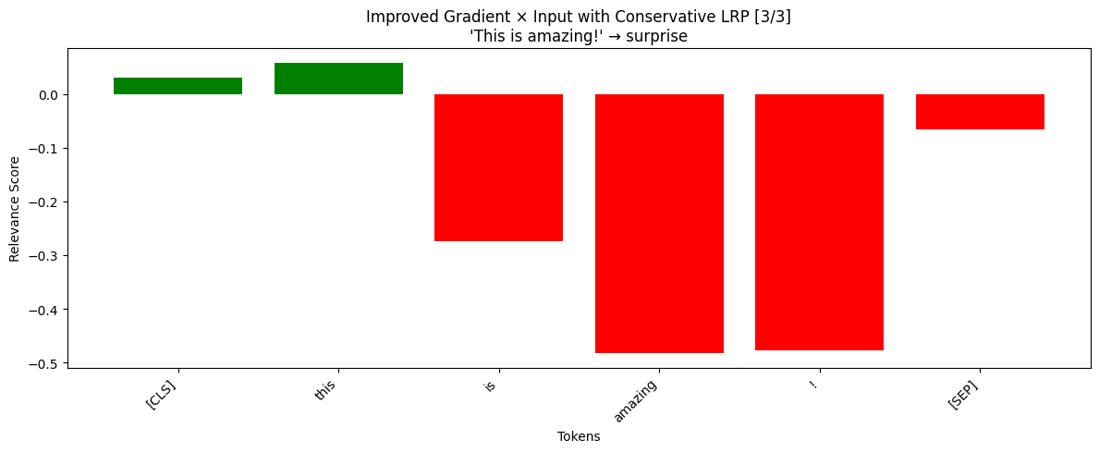
I think here we see the same problem as it was with the previous sentence. Model not aligning predictions with what it considers important and unimportant

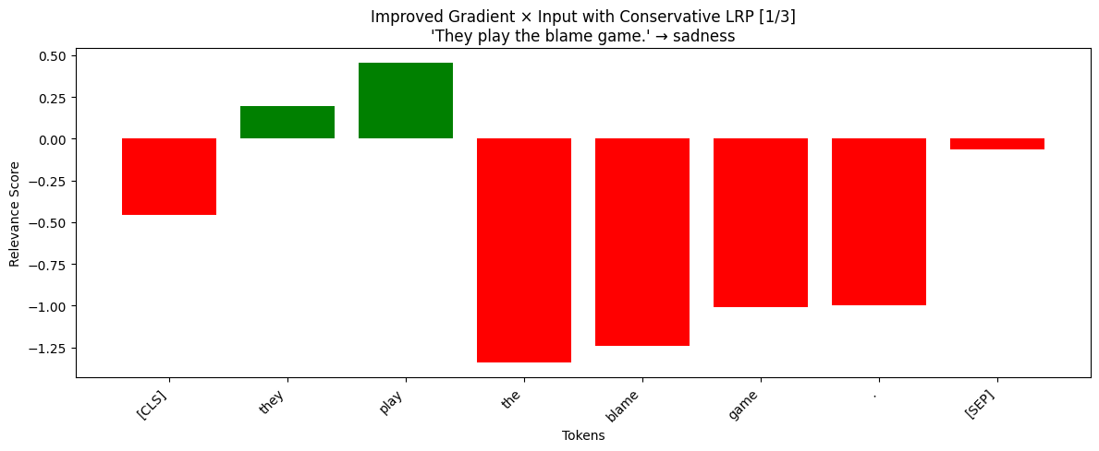
Anger
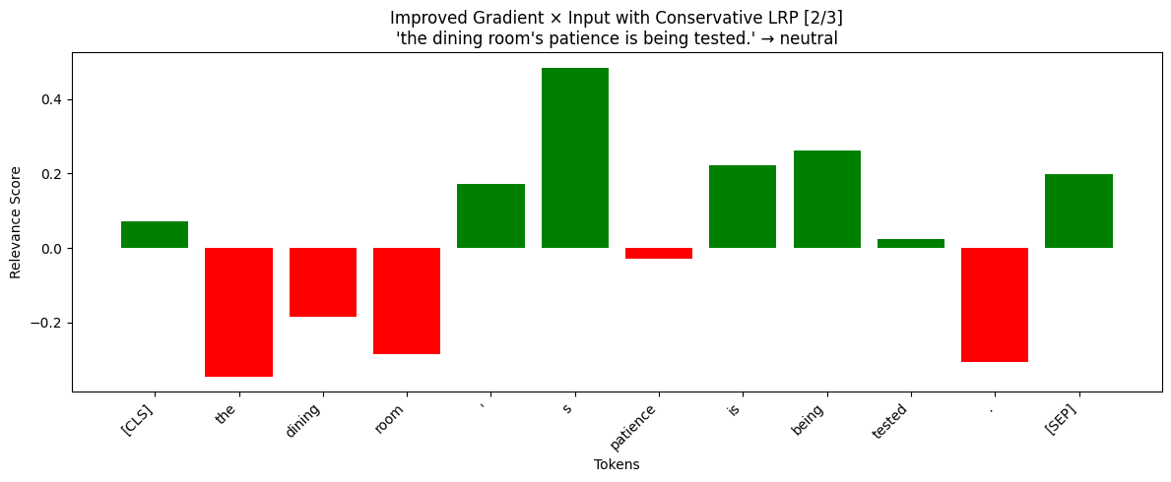
We are beginning to see the issues of the model. Most of the tokens are highly irrelevant to the sadness class, yet it is wrongly predicted. Although it is a surprise that not even token “blame” is not relevant to sadness.
For this sentence the correct emotionally relevant tokens had very little relevance (“patience” and “tested”). Overall this whole sentence is an issue for the model.
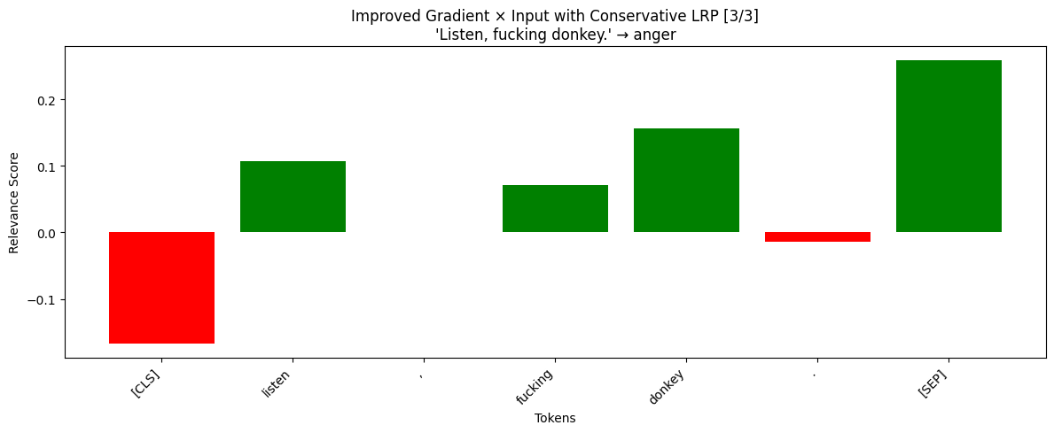
We see token [CLS] being highly irrelevant to anger, this might be a bias in our model, but luckily for this sentence the correct emotionally impactful tokens have relevancy when it comes to anger. This shows much clearer explanation than in the previous method.

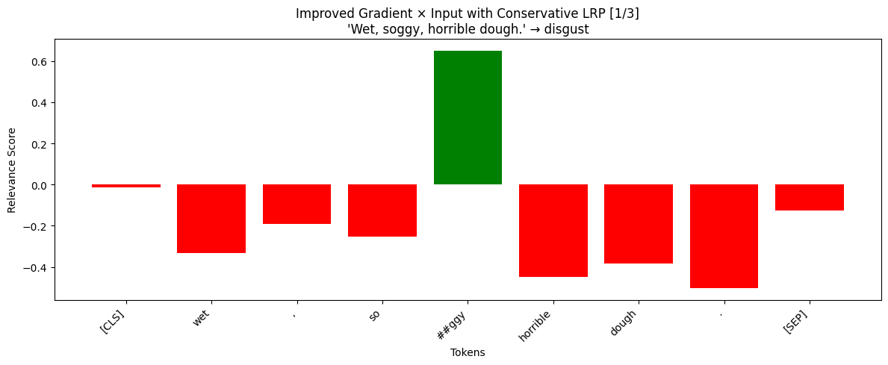
Disgust
This is very interesting to see, because for the basic method, the token “horrible” was relevant for the model, which made sense, but using this improved method, the token “##ggy” which is a word “soggy” split is now the only relevant token. All the other point towards different label. We are honestly not sure how to interpret this, whether the model is doing bad or good on this sentence. Because soggy may evoke disgust, but the token itself is not the entire word.

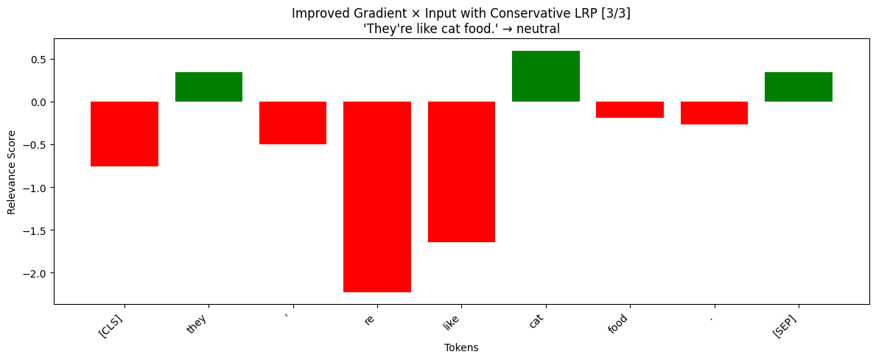
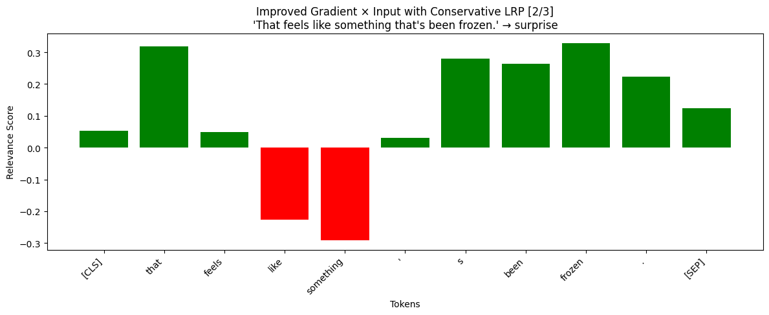
Results are pretty similar like the previous method. Although now we see that the tokens are much more relevant to the surprise even though the correct emotion should be disgust. This just proves us that the model might be struggling with this the disgust where it would need context to understand the sentence.
Here in the improved method, we can now see that the tokens are mostly negative pointing away from neutral, which is good, but the model still predicts wrong.

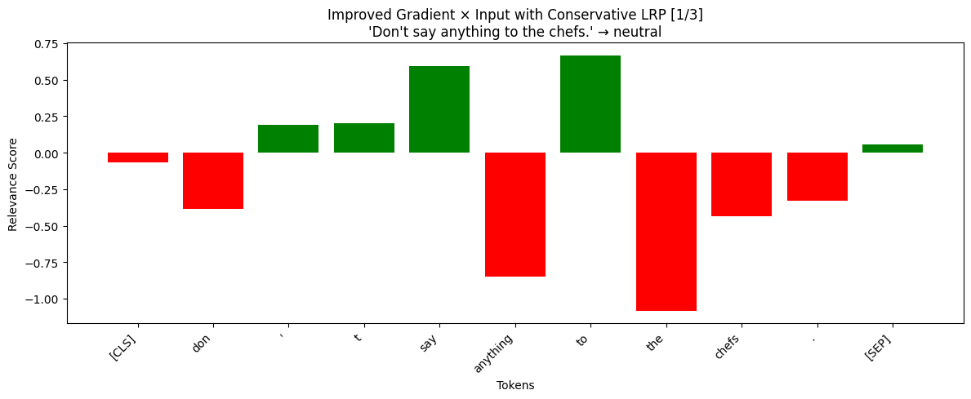
Fear
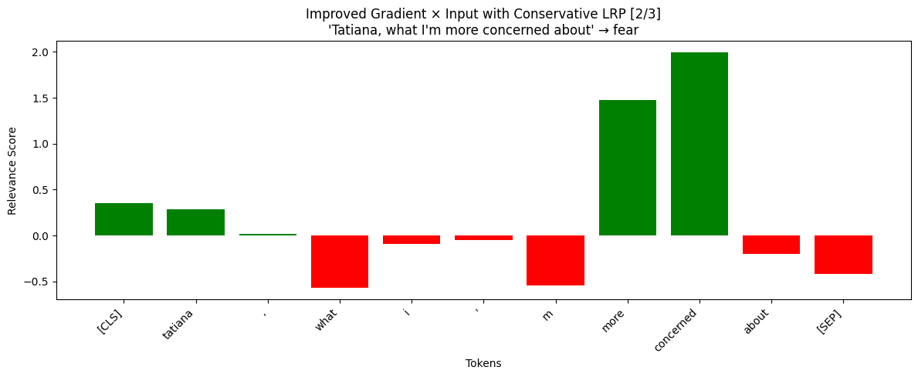
In the improved method more tokens seem to be irrelevant to neutral and point to another label. Tokens are emotionally learning towards other token like “don” or “anything” which is an improvement from the basic method.
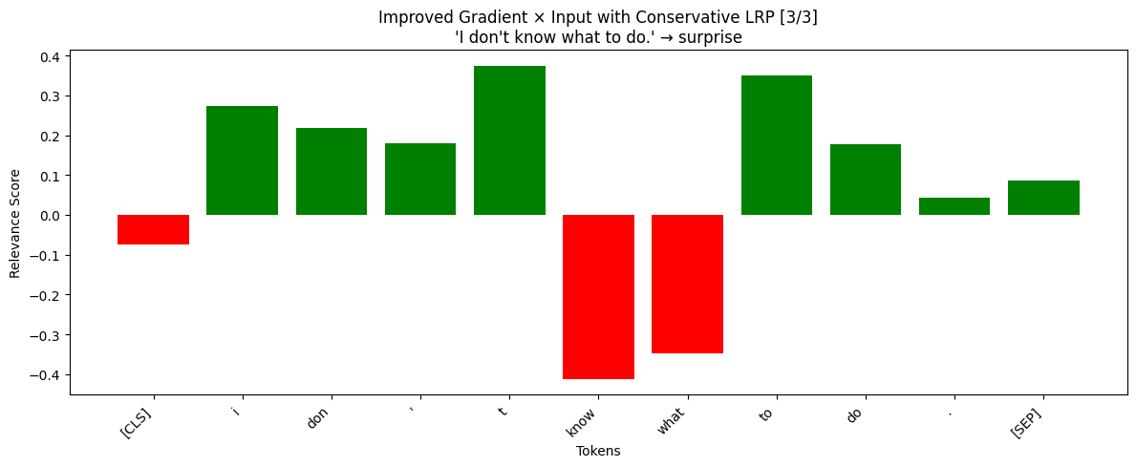
Difference in this is that now token “more” is also relevant for fear which in combination with “concerned” is an undeniable fear
This improved method showed us that the model is completely wrong with this sentence. It makes no for the tokens to be supportive of surprise label.

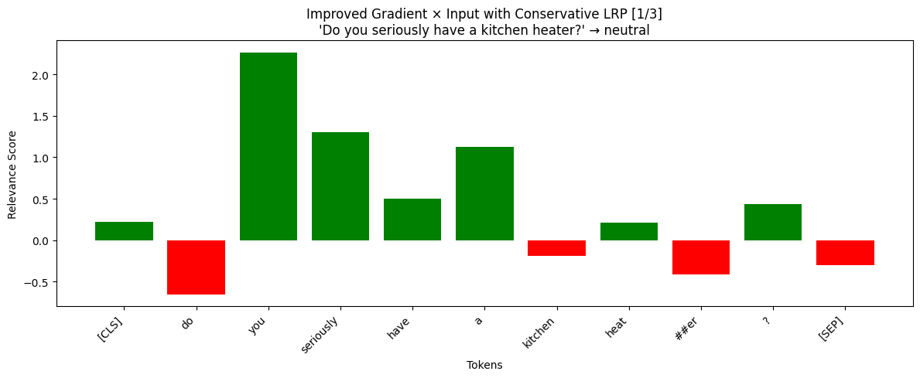
Surprise
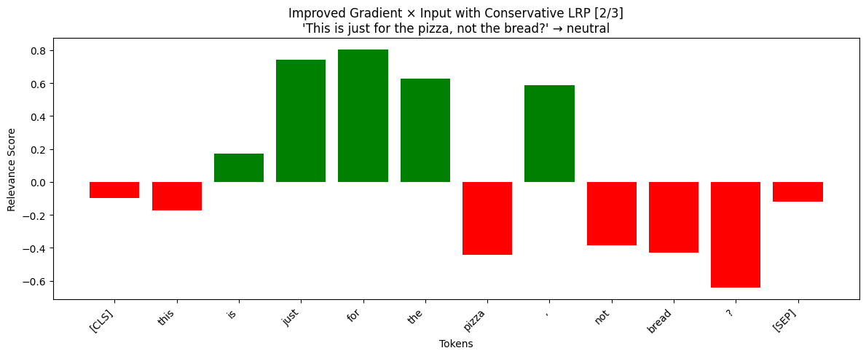
Here we again see that token like “seriously” should have been irrelevant to neutral, but it has the second highest relevancy for neutral instead of surprise. This shows that the model probably has trouble with surprise class
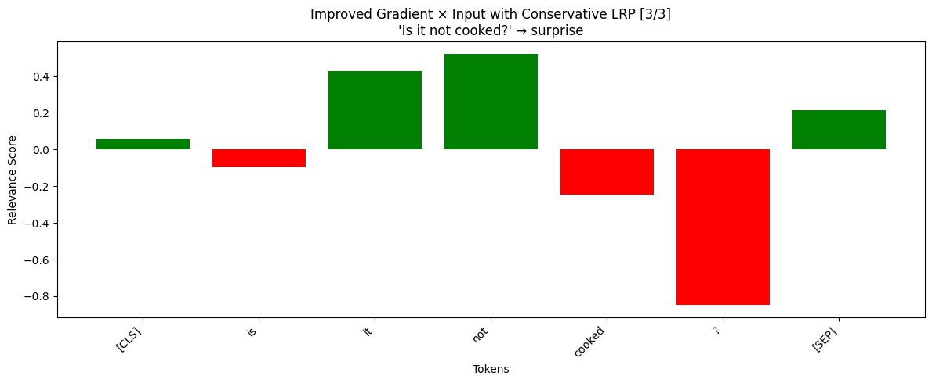
Looking over this sentence again, we could say that the first part is indeed neutral which the model correctly captures. Then the second part is more of a question/surprise. Luckily this part is not relevant to the neutral and now even the “?” token is pointing more towards another emotion. Unfortunately, the model still predicts neutral.
Although this sentence is correctly labeled, we are surprised to see that the “?” token is not indeed supporting the class. This makes us wonder and alerts us that the question mark may be wrongly interpreted.

Model Robustness with Input Perturbation
Now we evaluate the robustness of the model’s predictions when systematically removing tokens and we check the confidence changes. We can see which tokens are critical for the models’ decisions and we can analyze how robust the model is by looking at the sharpness of drops

Neutral
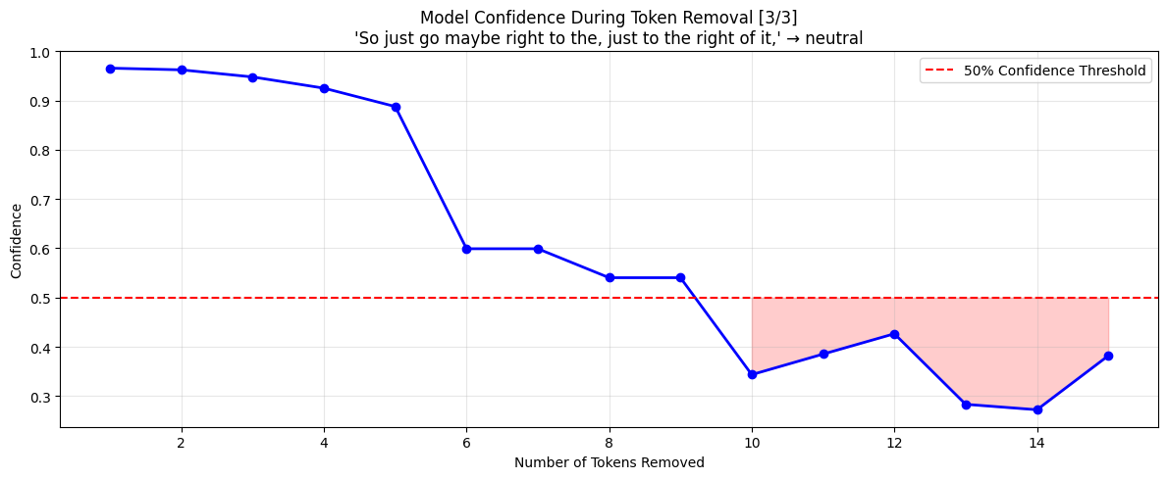
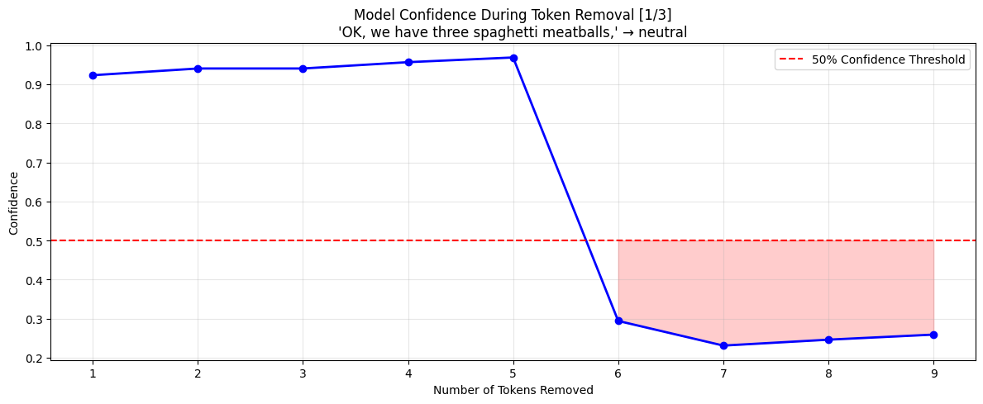
Looking at the whole neutral class, the model is still confident after an average of 5 tokens removed. Then it usueally starts to drop at once, or one by one.
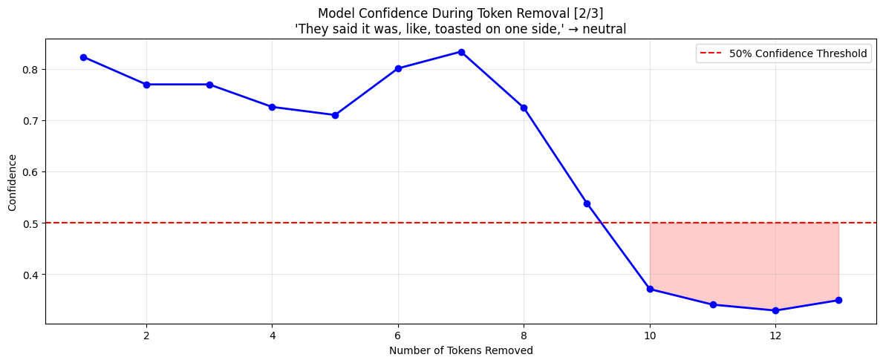

Happiness
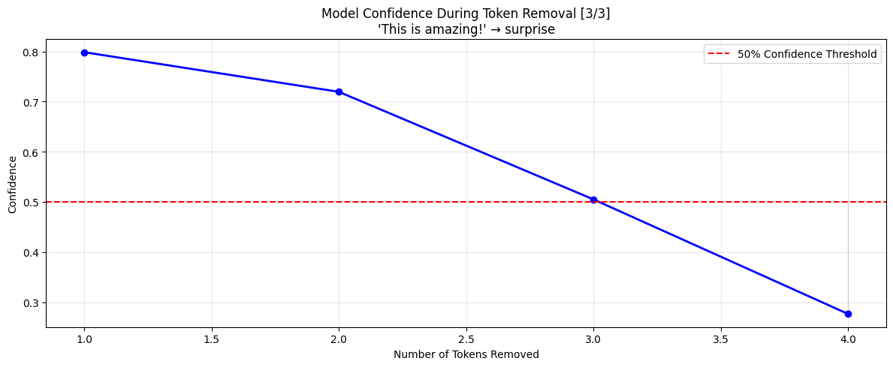
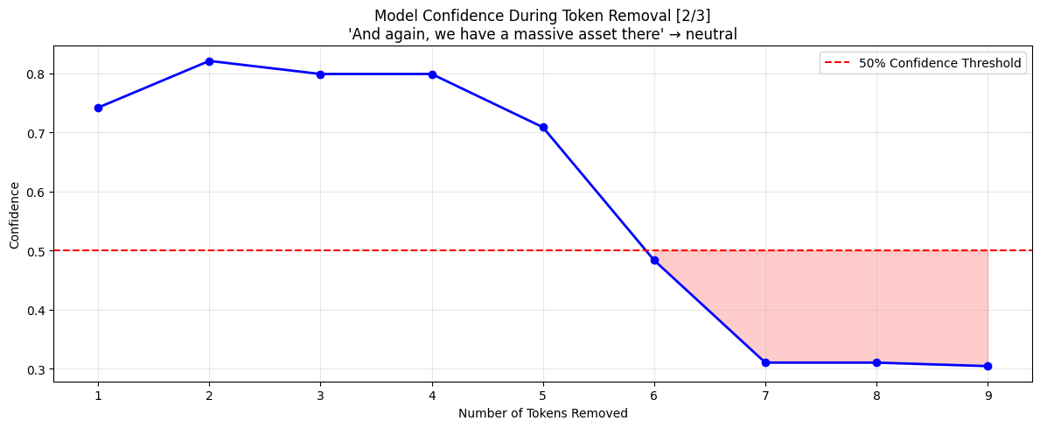
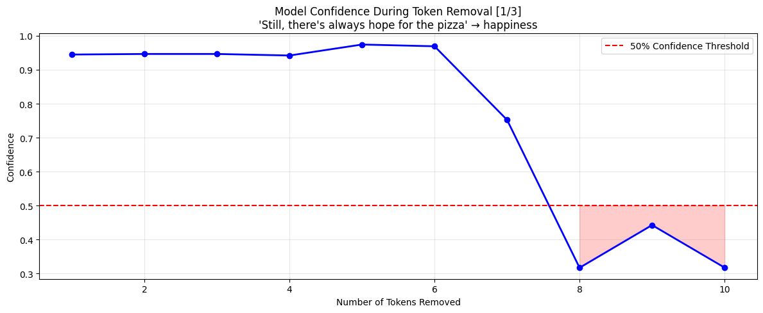
Happiness is also quite stable when it comes to longer sentences. The ability to be confident stays strong even after minimum of 5 tokens. However when a small sentence is present, the confidence drops to 50% after 3 token removals.

Sadness
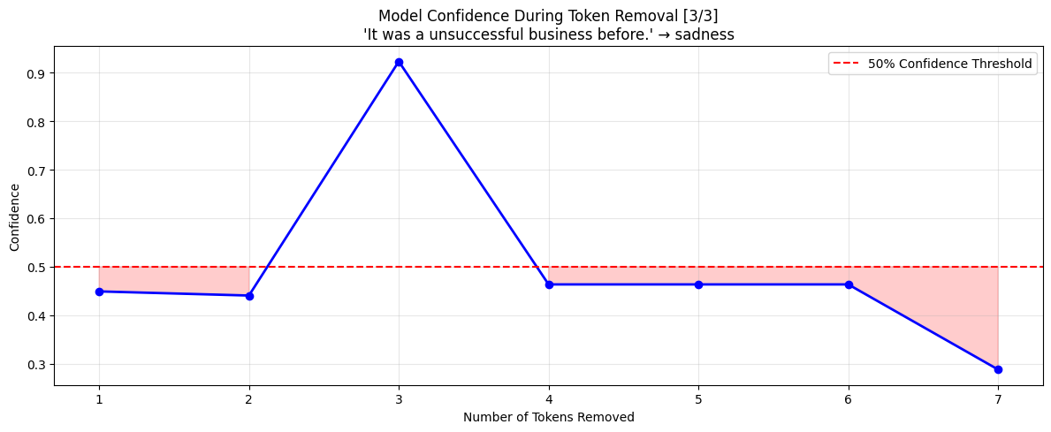
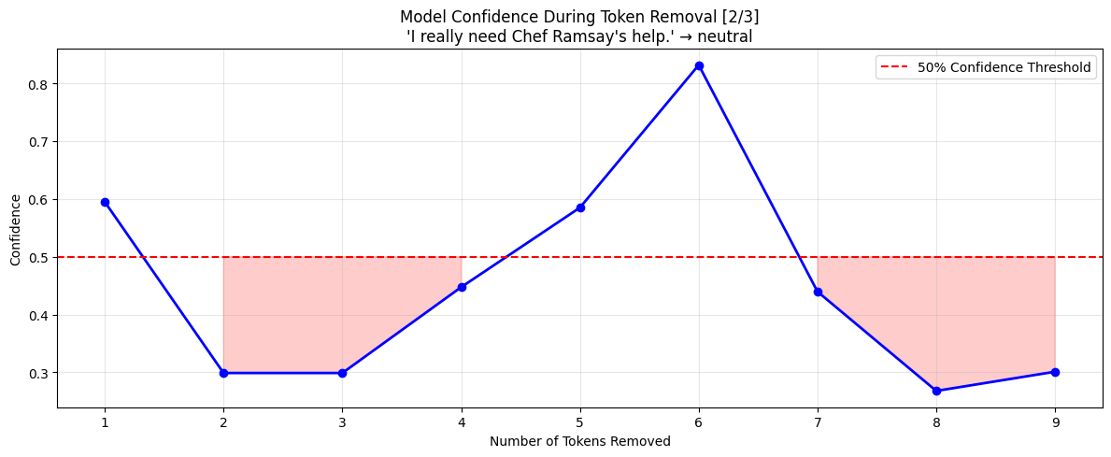
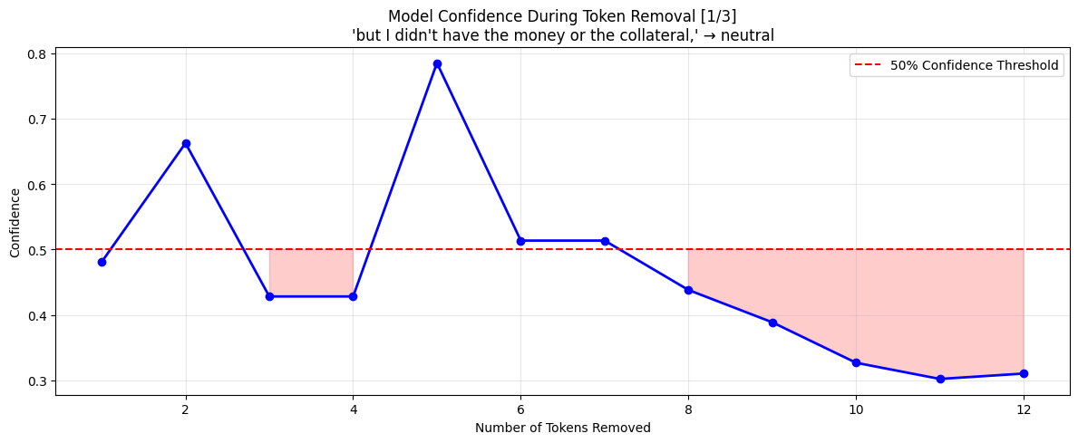
The models confidence for sadness is very volatile. The confidence drops and rises after different numbers of token removals. We could say that the model is not really robust to sadness. Even when the emotion is correctly labeled in the one case out of three, the volatily is the same

Anger
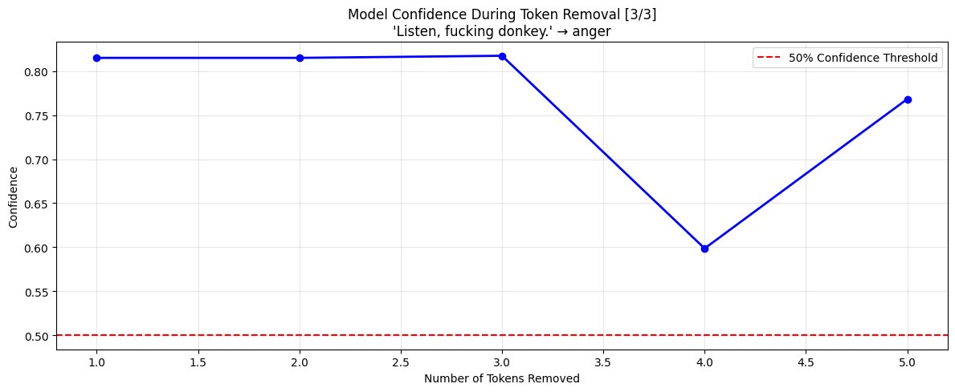
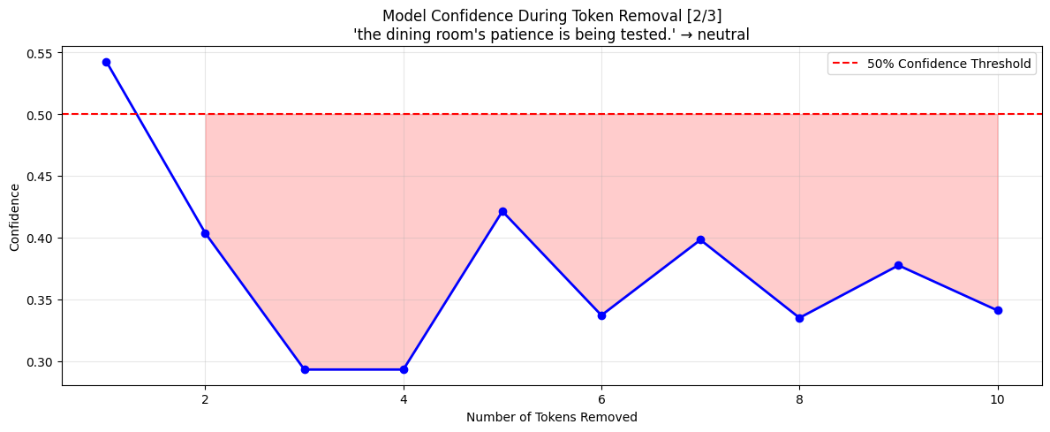
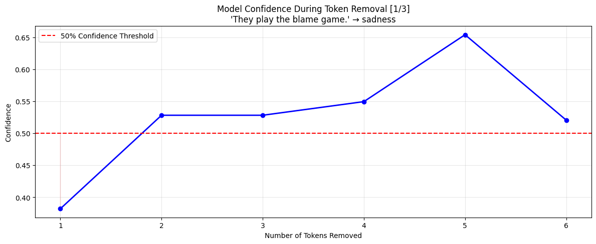
We see three different stability across the emotions. One seems to be rather stable where after more than one token removal the prediction stabilizes and stays above the threshold. Then we have an extreme where after two token removals the prediction is totally unstable and would probably point to another label. Finally the correctly labeled emotion seems to be very stable across all the token removals. So if the sentence is really charged with anger, the model is confident

Disgust
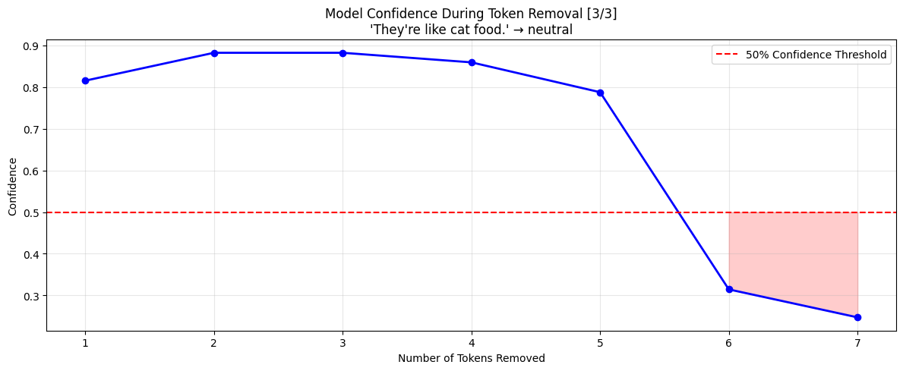
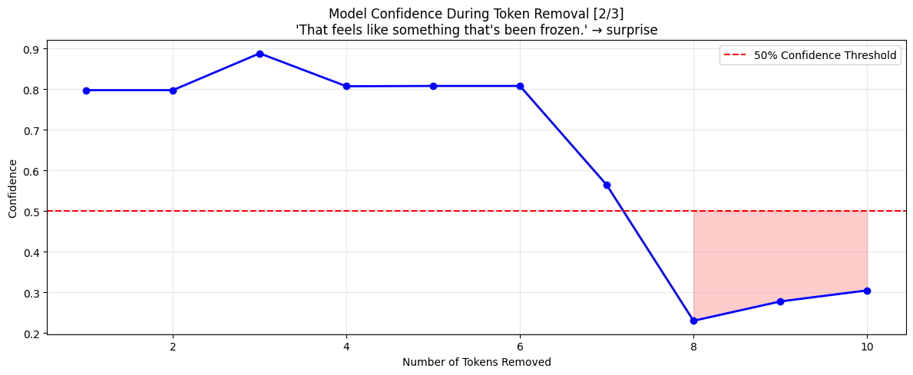
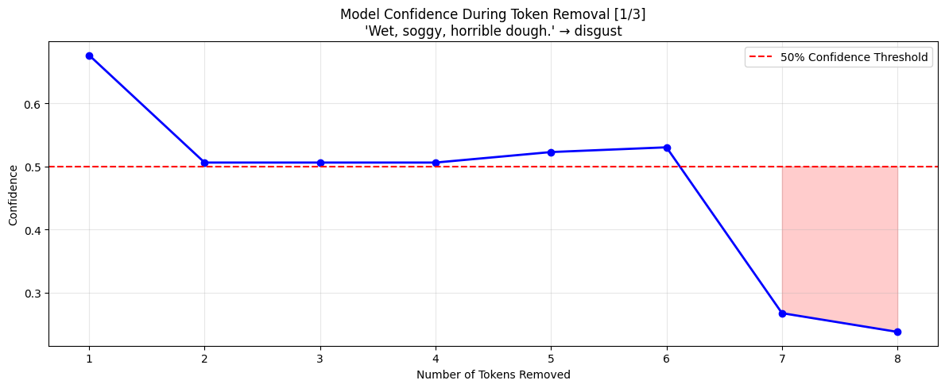
Models’ confidence for disgust is rather stable, one of the sentences was barely above the 50% threshold but still managed to be up. Usually the confidence drops after 6 to 7 token removals. After that number the confidence drops sharply and the predictions are unstable

Fear
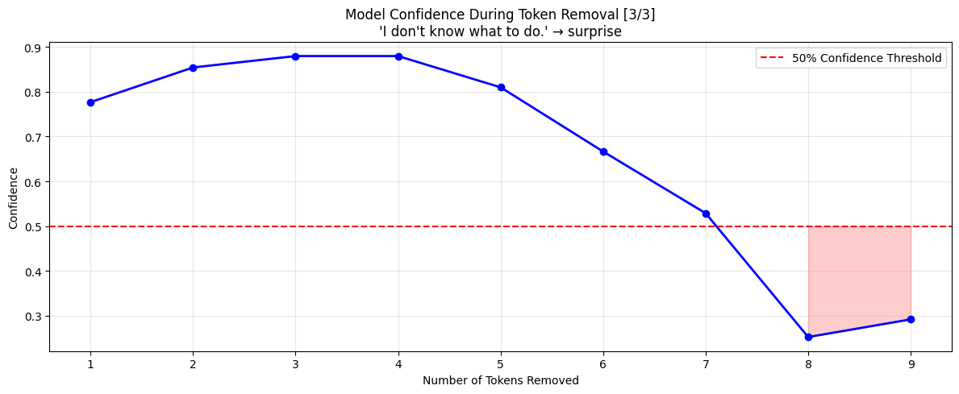
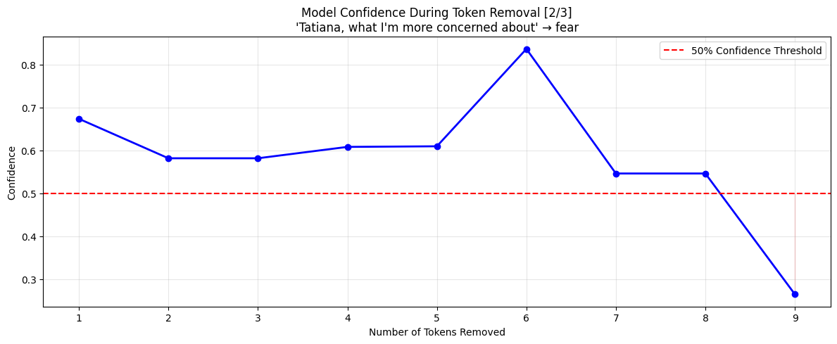
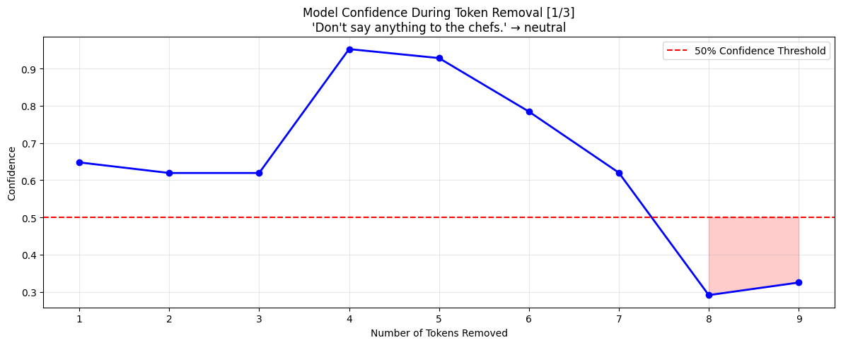
For fear the predictions are stable, they stay above the 50% and the after each token is removed, the confidence slowly degrades. This is considered rather stable behaviour.

Surprise
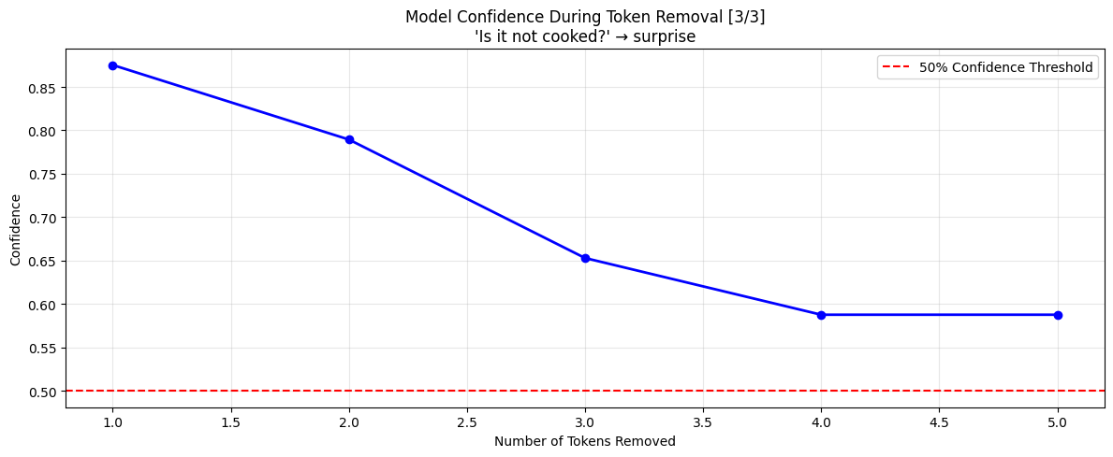
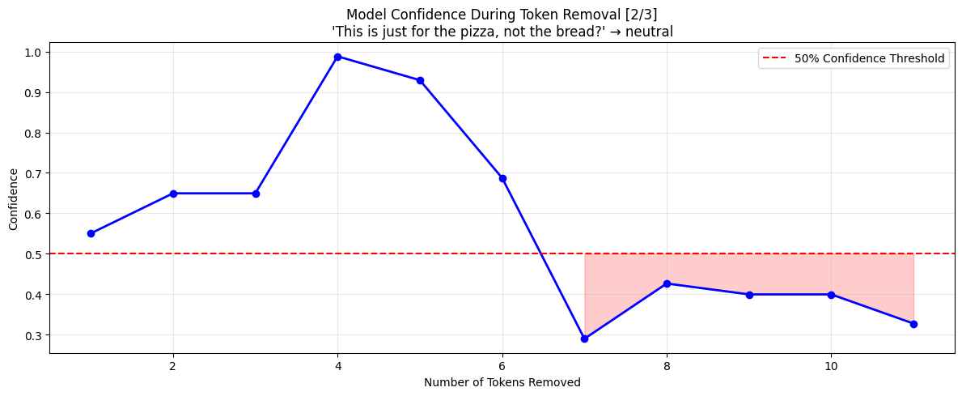
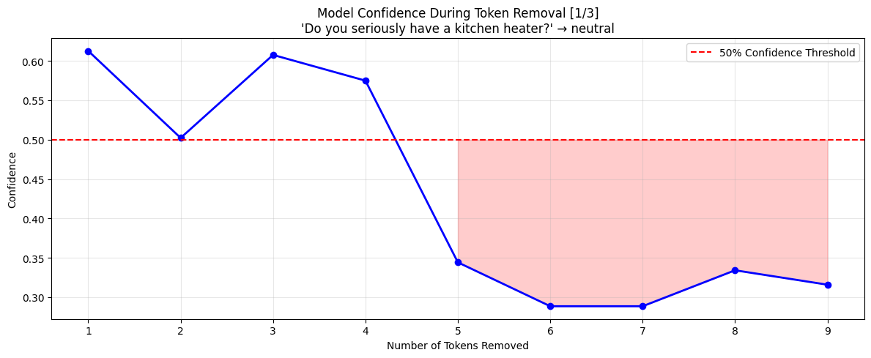
For this class, when the model correctly predicts surprise, it stays really confident after the token removals. For the other sentences, it does not take long after it stops being confident and at some point sharply drops below the threshold

